Project Artifacts for Group 103

Yijun Chen, Yushi Deng  
ychen3646@gatech.edu, ydeng319@gatech.edu

## **1. Source code**

* Link to GT GitHub repo: <https://github.com/ydeng319/IHI-project>
* Link to presentation: <https://youtu.be/Dps7X53fx6g>
* Link to deployed application: <http://3.141.42.112:8501/>

**2. Test data**

|  | **Test steps** | **Test data** | **Test Result** |
| --- | --- | --- | --- |
| Landing page | Users can click on [the app link](http://3.141.42.112:8501/) to access the app default page. | App link:<http://3.141.42.112:8501/> | On the app landing page, users can see a world map with all the bird flu cases as well as key metrics and case count. |
| Left panel | On the upper left side, users can click on the triangle icon to expand the left panel. In the left panel, users have 2 filter options, “country” and “date picker”. |  | Users see the left side panel expanded with 2 filter options. |
| Filter data using country dropdown | 1. Users can expand the country option and select “United States” from the list.  2. Users then click on “Filter Map and Summarize Data” button to save the data. | Country drop down: “United States” | The world map is now filtered with only US case data. Case count below the map is now 6488.  AI summary is generated to summarize case data represented in the map. |
| Filter data using date picker | 1. Users can expand the reporting date range and select “2016-01-01” and “2016-12-31” as the start and the end date.  2. Users then click on “Filter Map and Summarize Data” button to save the data. | Date picker start date: “2016-01-01”  Date picker start date: “2016-12-31” | The world map is now filtered with only US case data from 2016. Case count below the map is now 15.  AI summary is generated to summarize case data represented in the map. |
| Zoom in / out on map | Users can hover over the map and scroll with the mouse wheel. |  | Map will zoom in and out for users. |
| Data Export | Users can click on “Export data: button under the map. |  | Filtered new cases data will be exported to download file in csv file. |

**3. Technical / user documentation**

### **3.1 Tools/Technology**

Our project focuses on visualizing bird flu spread data with interactive timeline features. Tools and technologies used include:

| **Category** | **Tools/Technology** |
| --- | --- |
| Programming language | Python |
| Web Framework | Streamlit |
| Data Processing | Pandas, NumPy, Plotly |
| Hosting Server | Streamlit cloud or gcp |
| Version control | git |
| Repository Hosting | Github |
| LLM | Google AI Studio |

**4. Diagram or mockups**

### **4.1 Architecture Diagram**

The architecture diagram of this project is shown in Figure 1. The breakdown of the components and their relationships include:

1. **User:** Represents the end user who interacts with the system to visualize the bird flu spread trend
2. **Web App:** A web application that serves as the interface for the user. It's where the user views and interacts with the data visualizations. The web app is built using streamlit.
3. **Cloud Server:** Hosts the web application and manages the data flow between the web app and the GitHub repository.
4. **GitHub Repo:** Stores the application's code and possibly the bird flu data or scripts to fetch the data. It acts as a version control system and can also be part of the deployment pipeline.
5. **Data Visualization:** A python script for the date preprocessing and visualization pipeline, along with a web app, built using Streamlit, dedicated to visualizing the bird flu data effectively.
6. **Bird Flu Data:** The dataset that is used by the Streamlit component to create visualizations. It’s stored in a database or a similar data storage solution (e.g. csv file) accessible by the web app.

For an user accesses the web app hosted on a cloud server, which retrieves data visualizations powered by Streamlit from the bird flu data, and all updates or application code are managed through a GitHub repository.

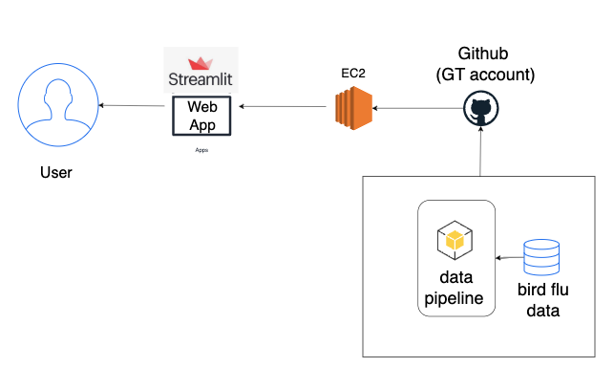

***Figure 1 - Architecture diagram***

### 

### 

### 

### 

### **4.2 UX**

Default overview where all the case observations are listed on the map from Figure 2 -4, together with some key metrics.

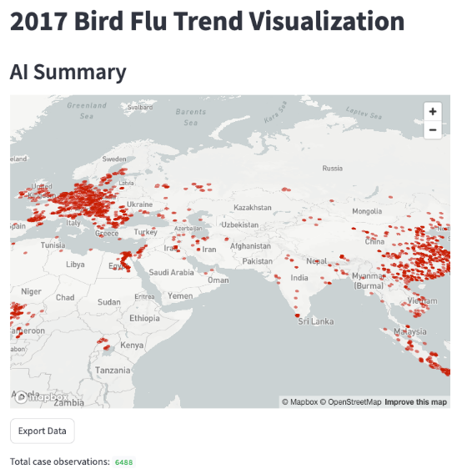

***(a)***

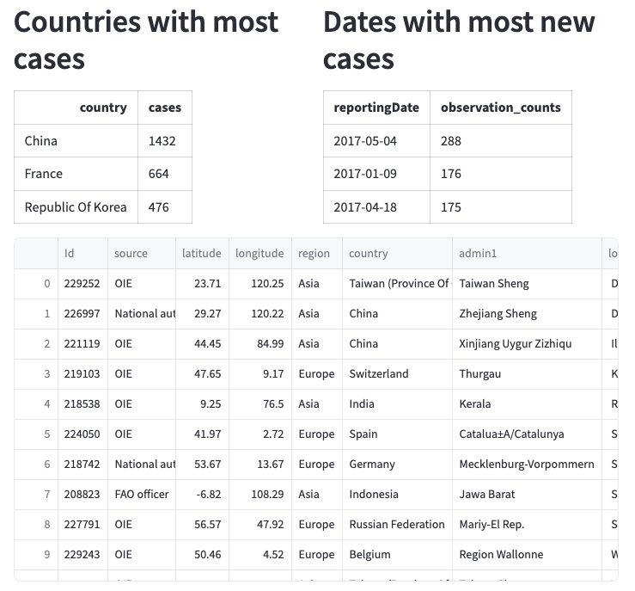

***(b)***

***Figure 2 - Default overview of UX***

A filter left panel that enables researchers to filter and review cases.

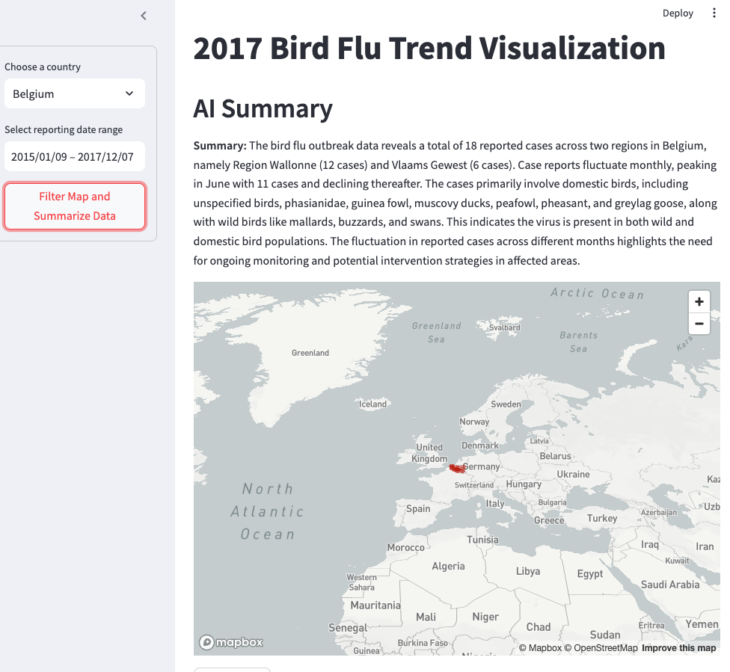

***Figure 3 - Overview for filtered cases***

A filtered view where users can zoom in to one or more countries and review case development closely.

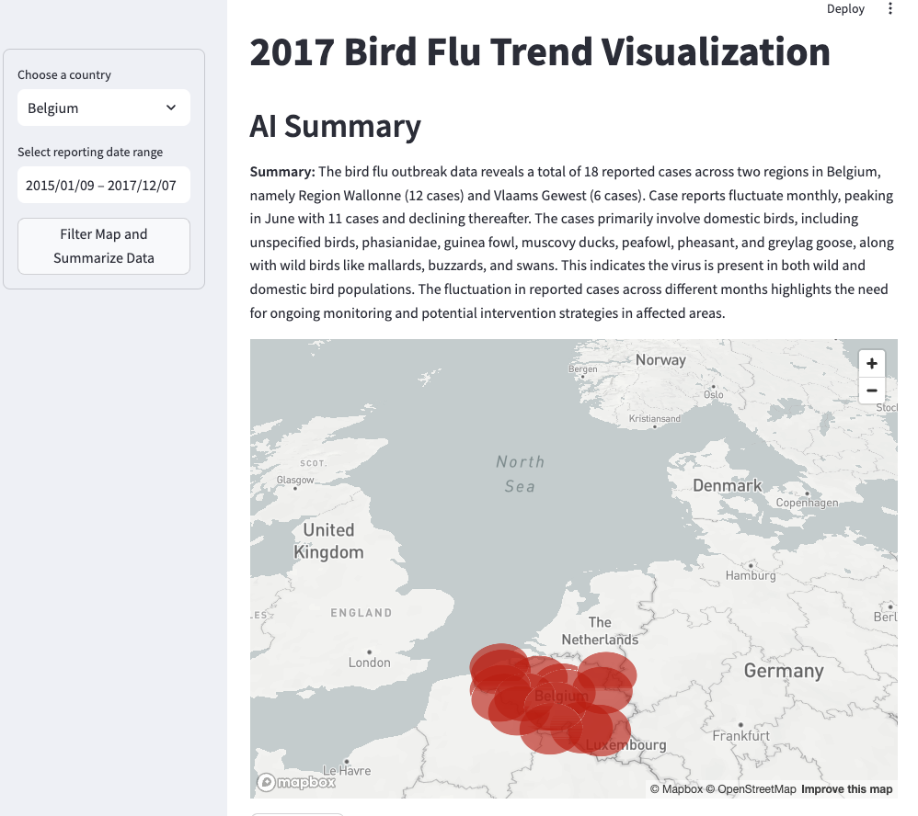

***Figure 4 - Overview for filtered cases after zoom in***